14

THE BASIC TOOLS OF FINANCE

WHAT’S NEW IN THE SEVENTH EDITION:

There are no major changes to this chapter.

LEARNING OBJECTIVES:

By the end of this chapter, students should understand:

➢ the relationship between present value and future value.

➢ the effects of compound growth.

➢ how risk-averse people reduce the risk they face.

➢ how asset prices are determined.

CONTEXT AND PURPOSE:

Chapter 14 is the third chapter in a four-chapter sequence on the level and growth of output in the long run. In Chapter 12, we discuss how capital and labor are among the primary determinants of output and growth. In Chapter 13, we addressed how saving and investment in capital goods affect the production of output. In Chapter 15, we will show some of the tools people and firms use when choosing capital projects in which to invest. Because both capital and labor are among the primary determinants of output, Chapter 15 will address the market for labor.
The purpose of Chapter 14 is to introduce the students to some tools that people use when they participate in financial markets. We will show how people compare different sums of money at different points in time, how they manage risk, and how these concepts combine to help determine the value of a financial asset, such as a share of stock.

KEY POINTS:

• Because savings can earn interest, a sum of money today is more valuable than the same sum of money in the future. A person can compare sums from different times using the concept of present value. The present value of any future sum is the amount that would be needed today, given prevailing interest rates, to produce that future sum.

• Because of diminishing marginal utility, most people are risk averse. Risk-averse people can reduce risk by buying insurance, diversifying their holdings, and choosing a portfolio with lower risk and lower return.

• The value of an asset equals the present value of the cash flows the owner will receive. For a share of stock, these cash flows include the stream of dividends and the final share price. According to the efficient markets hypothesis, financial markets process available information rationally, so a stock price always equals the best estimate of the value of the underlying business. Some economists question the efficient markets hypothesis, however, and believe that irrational psychological factors also influence asset prices.

CHAPTER OUTLINE:

I. Definition of finance: the field that studies how people make decisions regarding the allocation of resources over time and the handling of risk.

A. Many of the basic insights of finance are central to understanding how the economy works.

B. The tools of finance can help us think through some of the decisions that we must make in our lives.

II. Present Value: Measuring the Time Value of Money

A. Money today is more valuable than the same amount of money in the future.

B. Definition of present value: the amount of money today that would be needed, using prevailing interest rates, to produce a given future amount of money.

1. Example: you put $100 in a bank account today. How much will it be worth in N years?

2. Definition of future value: the amount of money in the future that an amount of money today will yield, given prevailing interest rates.

a. Definition of compounding: the accumulation of a sum of money in, say, a bank account where the interest earned remains in the account to earn additional interest in the future.

b. If we invest $100 at an interest rate of 5% for 10 years, the future value will be (1.05)¹⁰ × $100 = $163.

c. Example: You expect to receive $200 in N years. What is the present value of $200 that will be paid in N years?

i) To compute a present value from a future value, we divide by the factor (1 + r)^{N}.

ii) If the interest rate is 5% and the $200 will be received 10 years from now, the present value is $200/(1.05)¹⁰ = $123.
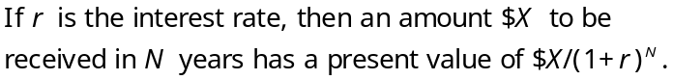

d. The higher the interest rate, the more you can earn by depositing your money at the bank, so the more attractive having $100 today becomes.

e. The concept of present value also helps to explain why investment is inversely related to the interest rate.

C. FYI: The Magic of Compounding and the Rule of 70

1. Growth rates that seem small in percentage terms seem large after they are compounded for many years.

2. Example: Finn and Quinn both graduate from college at the age of 22 and take jobs earning $30,000 per year.

a. Finn lives in an economy where incomes grow at 1% per year.

b. Quinn lives in an economy where incomes grow at 3% per year.

c. Forty years later (when both are 62), Finn will be earning $45,000 and Quinn will be earning $98,000.

3. The Rule of 70 can help us understand the effects of compounding:
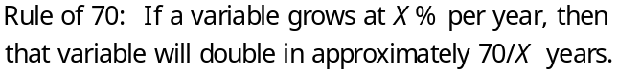

This is a good time to explain to students how important saving can be while they are young. Show students how the magic of compounding can turn a small amount of saving (say, $1,000 per year) into a large amount in 25 or 30 years.


III. Managing Risk

A. Risk Aversion

1. Most people are risk averse.

a. People dislike bad things happening to them.

b. In fact, they dislike bad things more than they like comparable good things.

c. For a risk-averse person, the pain from losing the $1,000 would exceed the pleasure from winning $1,000.

Figure 1
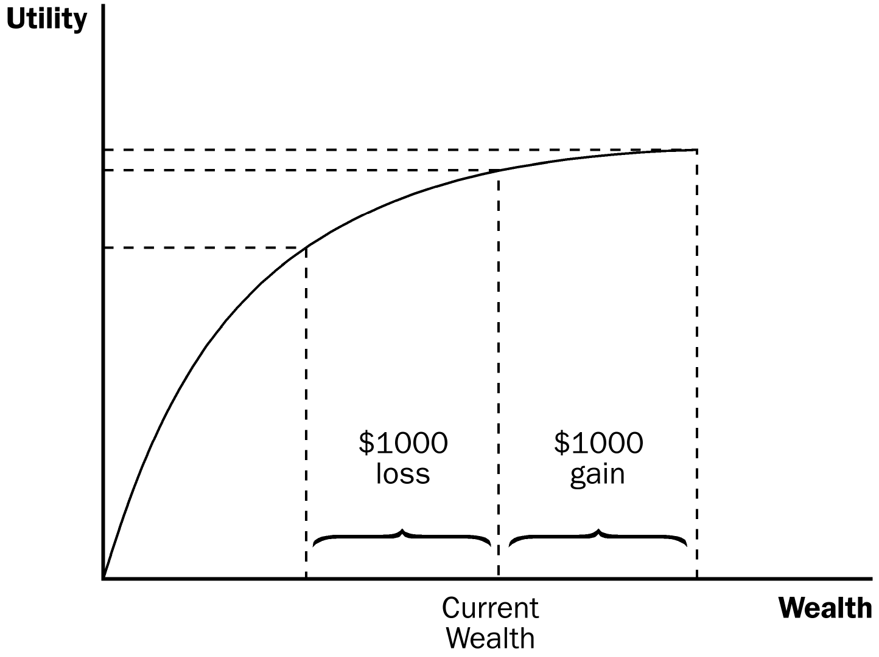

2. Economists have developed models of risk aversion using the concept of utility, which is a person’s subjective measure of well-being or satisfaction.

a. A utility function exhibits the property of diminishing marginal utility: the more wealth a person has, the less utility she gets from an additional dollar.

b. Because of diminishing marginal utility, the utility lost from losing $1,000 is greater than the utility of winning $1,000.

B. The Markets for Insurance

1. One way to deal with risk is to purchase insurance.

2. From the standpoint of the economy as a whole, the role of insurance is not to eliminate the risks inherent in life but to spread them around more efficiently.

a. Owning insurance does not prevent bad things from happening to you.

b. However, the risk is shared among thousands of insurance-company stockholders rather than being borne by you alone.

3. The markets for insurance suffer from two types of problems that impede their ability to spread risk.

a. A high-risk person is more likely to apply for insurance than a low-risk person because a high-risk person would benefit more from insurance protection. This is adverse selection.

b. After people buy insurance, they have less incentive to be careful about their risky behavior because the insurance company will cover much of the resulting losses. This is moral hazard.

C. Diversification of Firm-Specific Risk

1. Practical advice that finance offers to risk-averse people: “Don’t put all your eggs in one basket.”

2. Definition of diversification: the reduction of risk achieved by replacing a single risk with a large number of smaller unrelated risks.

a. A person who buys stock in a company is placing a bet on the future profitability of that company.

b. Risk can be reduced by placing a large number of small bets rather than a small number of large ones.

3. Risk can be measured by the standard deviation of a portfolio’s return.

a. Standard deviation measures the volatility of a variable.

b. The higher the standard deviation of a portfolio’s return, the riskier it is.

c. The risk of a stock portfolio falls as the number of stocks increases.

Figure 2

4. It is impossible to eliminate all risk by increasing the number of stocks in the portfolio.

a. Definition of firm-specific risk: risk that affects only a single economic actor.

b. Definition of market risk: risk that affects all economic actors at once.

c. Diversification can eliminate firm-specific risk, but will not affect market risk.

D. The Trade-off between Risk and Return

1. Principle #1: People face trade-offs.

2. Risk-averse people are willing to accept the risk inherent in holding stock because they are compensated for doing so.

3. When deciding how to allocate their savings, people have to decide how much risk they are willing to undertake to earn a higher return.

Figure 3

4. The choice of a particular combination of risk and return depends on a person’s risk aversion, which reflects her own preferences.

IV. Asset Valuation

A. The price of a share of stock is determined by supply and demand.

B. To understand stock prices, we need to understand what determines a person’s willingness to pay for a share of stock.

C. Fundamental Analysis

1. Definition of fundamental analysis: the study of a company’s accounting statements and future prospects to determine its value.

2. If the price of a share of stock is less than the value, the stock is said to be undervalued.

3. If the price of a share of stock is greater than its value, the stock is said to be overvalued.

4. If the price of a share of stock is equal to its value, the stock is said to be fairly valued.

5. The value of a stock to a shareholder is what she receives from owning it, which includes the present value of dividend payments and the final sale price.

a. Both of these are highly related to the firm’s ability to earn profits.

b. The firm’s profitability depends on a large number of factors that affect the demand for its product and its costs of doing business.

6. There are three ways to rely on fundamental analysis to select a stock portfolio.

a. Do all of the necessary research yourself.

b. Rely on the advice of Wall Street analysts.

c. Buy shares in a mutual fund.

D. The Efficient Markets Hypothesis

1. Definition of the efficient markets hypothesis: the theory according to which asset prices reflect all publicly available information about the value of an asset.

2. Each company listed on a major stock exchange is followed closely by money managers who monitor news stories and conduct fundamental analysis to determine a stock’s value.

3. At the equilibrium market price of a share of stock, the number of shares being offered for sale is exactly equal to the number of shares that people want to buy.

a. At the market price, the number of people who think that the stock is overvalued exactly balances the number of people who think it is undervalued.

b. As judged by the typical person in the market, all stocks are fairly valued all of the time.

4. Definition of informationally efficient: reflecting all available information in a rational way.

a. Stock prices change when information changes.

b. When the good (bad) news about a company’s prospects becomes public, the value and the price of the stock will rise (fall).

5. Definition of random walk: the path of a variable whose changes are hard to predict.

a. Changes in stock prices are impossible to predict from available information.

b. The only thing that can move stock prices is news that changes the market’s perception of the company’s value.

c. Because news is unpredictable, changes in stock prices should be unpredictable.

6. Case Study: Random Walks and Index Funds

a. Some of the best evidence in favor of the efficient markets hypothesis comes from the performance of index funds.

b. In practice, funds that are actively managed by a professional rarely beat index funds and often do worse.

E. Market Irrationality

1. The efficient markets hypothesis assumes that people buying and selling stock rationally process all of the information they have about the stock’s underlying value.

2. There is a long tradition suggesting that fluctuations in stock prices are partly psychological.

a. In the 1930s, John Maynard Keynes suggested that asset markets are driven by the “animal spirits” of investors.

b. In the 1990s, Federal Reserve Chairman Alan Greenspan questioned whether the stock market boom was due to "irrational exuberance.”

3. The value of a stock depends on the final sale price expected in the future.

a. A person may be willing to pay more than a stock is worth today if he believes that another person will pay even more in the future.

b. Therefore, to evaluate a stock, you have to estimate not only the value of the business but also what other people may believe the business is worth in the future.

4. There is much debate among economists about whether departures from rational pricing are important or rare.

a. Believers in market irrationality point out that the stock market often moves in ways that are hard to explain on the basis of news that might alter a rational valuation.

b. Believers in the efficient markets hypothesis point out that it is difficult to know the correct, rational valuation of a company so it is hard to tell if any particular valuation is irrational.

F. In the News: Is the Efficient Markets Hypothesis Kaput?

1. Some individuals suggest that the financial crisis of 2008 and 2009 indicates that the efficient markets hypothesis is wrong.

2. This article from The Wall Street Journal presents the contrary argument.

SOLUTIONS TO TEXT PROBLEMS:

Quick Quizzes

1. The present value of $150 to be received in 10 years if the interest rate is 7 percent is $150 / (1.07)¹⁰ = $76.25.

2. There are three ways in which a risk-averse person may reduce the risk she faces: (1) purchase insurance, (2) diversify her portfolio, or (3) choose safer alternatives by accepting a lower rate of return.

3. No. According to the efficient markets hypothesis, the price of a share of stock should reflect all available information about its value. Thus, the stocks on this list should perform no better on average than other stocks listed on the stock exchange.

Questions for Review

1. If the interest rate is 7%, the present value of $200 to be received in 10 years is $200/(1.07)¹⁰ = $101.67. If the interest rate is 7%, the present value of $300 to be received 20 years from now is $300/(1.07)²⁰ = $77.53. Given the choice between the two options, $200 to be received in 10 years is preferred to $300 to be received in 20 years.

2. Purchasing insurance allows an individual to reduce the level of risk he faces. Two problems that impede the insurance market from working correctly are adverse selection and moral hazard. Adverse selection occurs because a high-risk person is more likely to apply for insurance than a low-risk person is. Moral hazard occurs because people have less incentive to be careful about their risky behavior after they purchase insurance.

3. Diversification is the reduction of risk achieved by replacing a single risk with a large number of smaller unrelated risks. A stockholder will get a greater benefit from diversification going from 1 to 10 stocks than from 100 to 120 stocks.

4. Stocks have more risk because their value depends on the future value of the firm. Because of its higher risk, shareholders will demand a higher return than bondholders. There is a positive relationship between risk and return.

5. A stock analyst will consider the future profitability of a firm when determining the value of the stock.

6. The efficient markets hypothesis suggests that stock prices reflect all available information. This means that we cannot use current information to predict future changes in stock prices. One piece of evidence that supports this theory is the fact that many index funds outperform mutual funds that are actively managed by a professional portfolio manager.

7. Economists who are skeptical of the efficient markets hypothesis believe that fluctuations in stock prices are partly psychological. People may in fact be willing to purchase a stock that is overvalued if they believe that someone will be willing to pay even more in the future. This means that the stock price may not be a rational valuation of the firm.

Quick Check Multiple Choice
1. b
2. d
3. b
4. c
5. c
6. a

Problems and Applications

1. The future value of $24 invested for 400 years at an interest rate of 7% is (1.07)⁴⁰⁰ × $24 = $13,600,000,000,000 = $13.6 trillion.

2. a. The present value of $15 million to be received in four years at an interest rate of 11% is $15 million/(1.11)⁴ = $9.88 million. Because the present value of the payoff is less than the cost, the project should not be undertaken.

The present value of $15 million to be received in four years at an interest rate of 10% is $15 million/(1.10)⁴ = $10.25 million. Because the present value of the payoff is greater than the cost, the project should be undertaken.

The present value of $15 million to be received in four years at an interest rate of 9% is $15 million/(1.09)⁴ = $10.63 million. Because the present value of the payoff is greater than the cost, the project should be undertaken.

The present value of $15 million to be received in four years at an interest rate of 8% is $15 million/(1.08)⁴ = $11.03 million. Because the present value of the payoff is greater than the cost, the project should be undertaken.

b. The exact cutoff for the interest rate between profitability and nonprofitability is the interest rate that will equate the present value of receiving $15 million in four years with the current cost of the project ($10 million):

$10 = 15/(1 + x)⁴
10(1 + x)⁴ = 15
(1 + x)⁴ = 1.5
1 + x = (1.5)^{0.25}
1 + x = 1.10668
x = 0.10668

Therefore, an interest rate of 10.668% would be the cutoff between profitability and nonprofitability.

3. a. Using the rule of 70, when the interest rate is 3.5 percent, the value of the bond will double in approximately (70/3.5 =) 20 years. Therefore the value today of Bond A, which matures in 20 years, is approximately $4,000 because its value will double once in 20 years. The value today of Bond B, which matures in 40 years, is approximately $2,000 because its value will double twice in 40 years to $8,000. (More specifically, its value today is $2,000 and its value will double to $4,000 in 20 years and will double again to the $8,000 maturity value in 20 more years.)

b. Using the rule of 70, when the interest rate is 7 percent the value of the bond will double in approximately (70/7 = ) 10 years. Therefore, the value today of Bond A, which matures in 20 years, is approximately $2,000 because its value will double twice in 20 years. Today's value of Bond B, which matures in 40 years, is approximately $500 because its value will double 4 times in 40 years.

The percentage change in value for Bond A: (2000-4000)/4000 x 100 = -50%
The percentage change in value for Bond B: (500-2000)/2000 x 100 = -75%.

c. The value of a bond falls when the interest rate increases, and bonds with a longer time to maturity are more sensitive to changes in the interest rate.

4. The value of the stock is equal to the present value of its dividends and its final sale price. This is equal to $5/1.08 + $5/(1.08)² + ($5 + $120)/(1.08)³ = $4.63 + $4.29 + $99.23 = $108.15. Since this is lower than the initial selling price of $110, XYZ stock is not a good investment.

5. a. A sick person is more likely to apply for health insurance than a well person is. This is adverse selection. Once a person has health insurance, he may be less likely to take good care of himself. This is moral hazard.

b. A risky driver is more likely than a safe driver to apply for car insurance. This is adverse selection. Once a driver has insurance, he may drive more recklessly. This is adverse selection.

6. A stock that is very sensitive to economic conditions will have more risk associated with it. Thus, we would expect that stock to pay a higher return. To get stockholders to be willing to accept the risk, the expected return must be larger than the return on a less-risky asset.

7. Shareholders will likely demand a higher return due to the stock’s firm-specific risk. Firm-specific risk is risk that affects only that particular stock. All stocks in the economy are subject to market risk.

8. a. Answers will vary, but may include things like information on new products under development or information concerning future government regulations that will affect the profitability of the firm.

b. The fact that those who trade stocks based on inside information earn very high rates of return does not violate the efficient markets hypothesis. The efficient market hypothesis suggests that the price of a stock reflects all available information concerning the future profitability of the firm. Inside information is not readily available to the public and thus is not reflected in the stock’s price.

c. Insider trading is illegal because it gives some buyers or sellers an unfair advantage in the stock market.

9. a. Yes, Jamal is risk averse. The marginal utility of an additional dollar of wealth is diminishing. Figure 1 shows Jamal’s utility function.

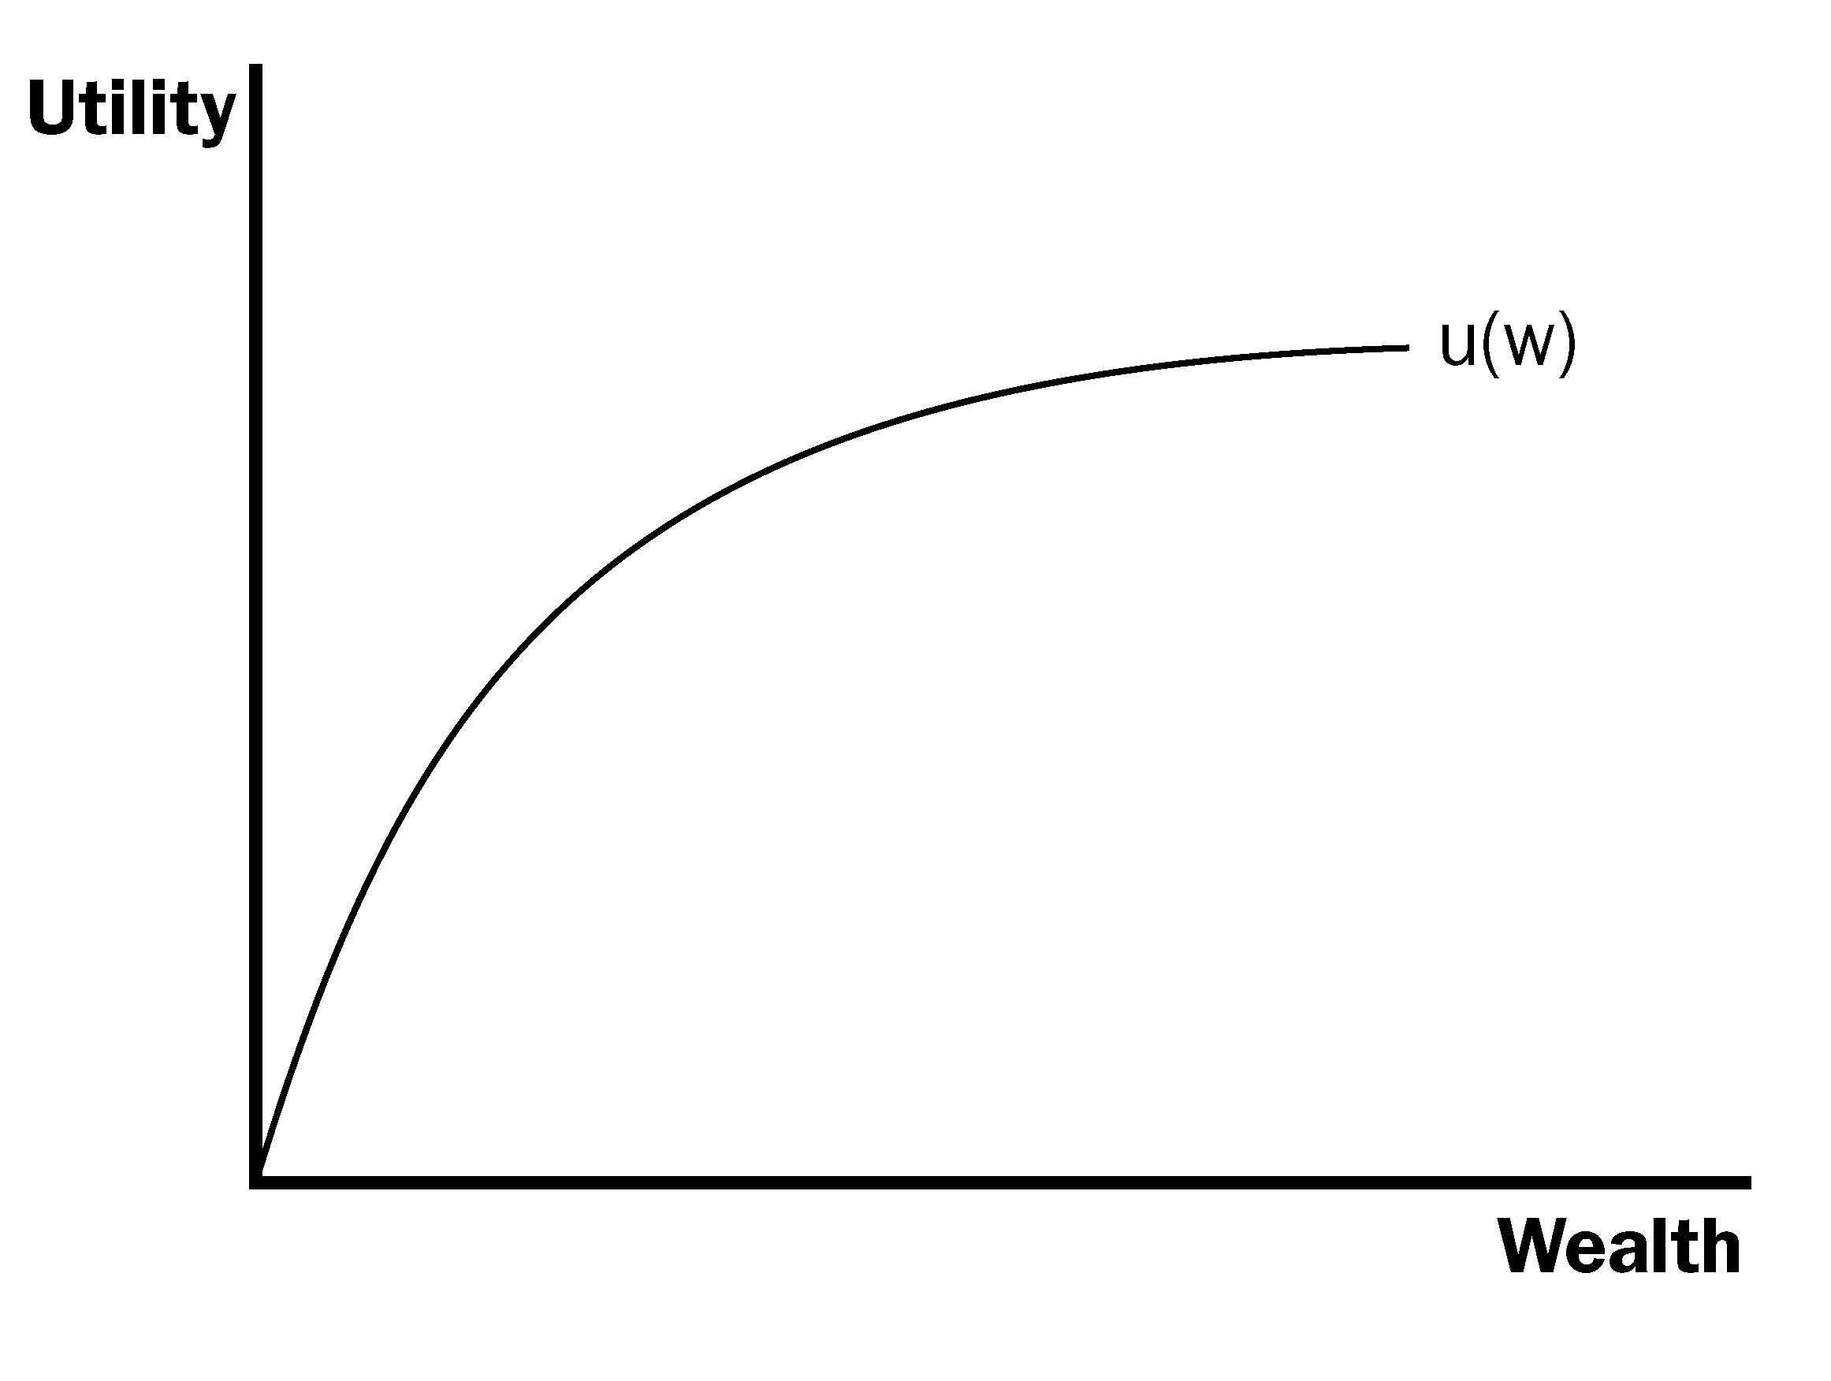

Figure 1

b. The expected value of option A = U(W = $4 million) = 2,000.

The expected value of option B = (0.6) × U(W = $1 million) + 0.4 × U(W = $9 million) = (0.6) × 1,000 + (0.4) × 3,000 = 600 + 1,200 = 1,800.

Jamal should choose option A.

